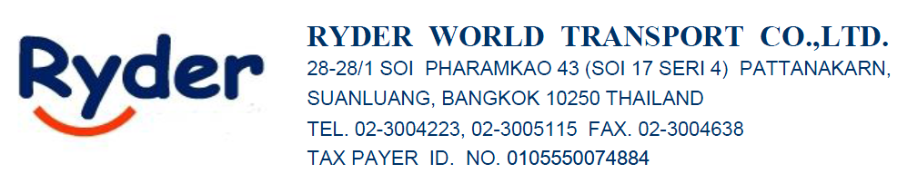21/5/26

ATTN : K.MUT

FROM : Sirisak Srisuwan (Sam) 065-625-4945

AIR FREIGHT RATE QUOTATION (IMPORT-LCL) EX-Work

Port/Country | Ocean Freight | CLS  CLOSING EXPORT ENTRY & VGM WITHIN FRIDAY | ETD | T/T
Port/Country | LCL | CLS  CLOSING EXPORT ENTRY & VGM WITHIN FRIDAY | ETD | T/T
NINGBO | $30/CBM | MON/TUE/THU | FRI/SAT/MON | 10 DAYS

LOCALCHARGE IN BKK
CFS : THB500/RT
THC : THB500/RT
STS : THB150/RT
FAC : THB100/RT
D/O : THB1,500/SET
HANDLING : THB 500/SET
CUSTOM CHARGE : 1,800 Baht/Set
TRANSPORT : 5,500-6,500 Baht
FREE ZONE : 1,500 Baht

LOCALCHARGE EX-WORK
EBS+CIC : USD 18/RT
DOC : USD 45/SET
CUSTOM CLEARANCE : USD 45/SET
PICK UP CHARGE : USD 120/TRUCK
H/C : USD 30/SET

Best Regards,
Sirisak Srisuwan (Sam)
Sales
Ryder World Transport Co., Ltd.
28-28/1 Soi Pharamkao 43 (Soi 17 Seri 4)
Pattanakarn, Suanluang, Bangkok 10250 THAILAND
Tel: (662)300 4223, (662)300 5115 (Ext. 215)
Mobile: (66)65-625-4945
Fax: (662)300 5092
Website: www.ryder.co.th

